Monday | Tuesday | Wednesday | Thursday | Friday
 | 1 | 2 | 3    Wear Red, White, and Blue!  Parade at 10:00 | 4 4th of July  Milestones Closed!  Have A Safe & Happy Holiday!
7 | 8 | 9 | 10 | 11
14  Dress To Impress | 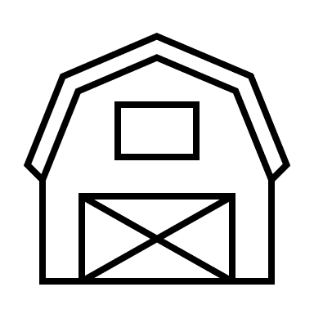  15  Down On The Farm –  Dress Like A Farmer | 16  Tie Dye Day |   17  Christmas In July | 18  Camp Out
21  Lockdown  10:00 | 22 | 23 | 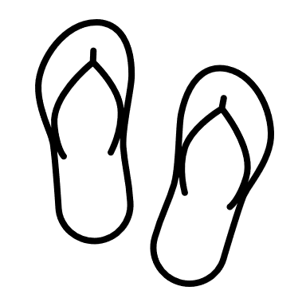  24 | 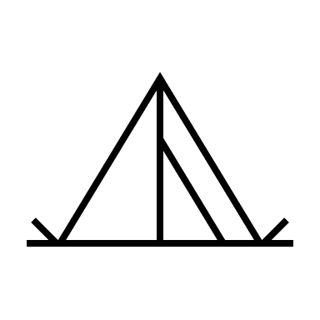  25
28 | 29 | 30 | 31

