Monday | Tuesday | Wednesday | Thursday | Friday
 |  | 1  Happy New Year  Milestones closed | 2 | 3
6 | 7 | 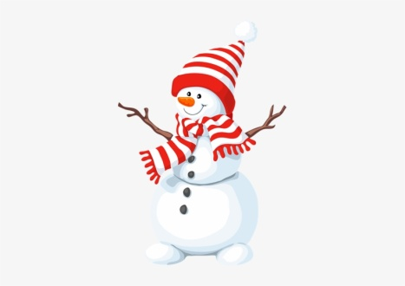  8 | 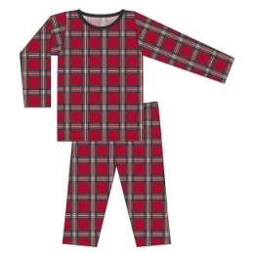  9 | 10
13  Toboggan Day | 14  Shimmer & Shine Day | 15  Snowman Day | 16  Pajama Day | 17  Silver, Blue, White Day
20 | 21 | 22 | 23 | 24
27 | 28 | 29 | 30 | 31

