Monday | Tuesday | Wednesday | Thursday | Friday
1 | 2 | 3    Wear Red, White, and Blue!  Parade at 10:00 | 4  Milestones Closed!  Have A Safe & Happy Holiday! | 5
8 | 9 | 10 | 11 | 12
15  Dress To Impress | 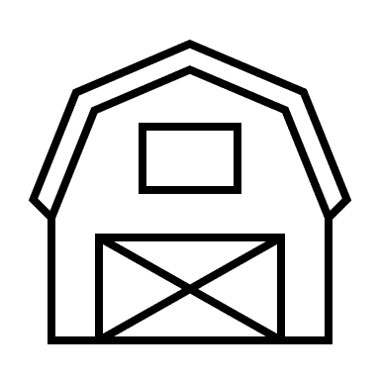  16  Down On The Farm –  Dress Like A Farmer | 17  Tie Dye Day | 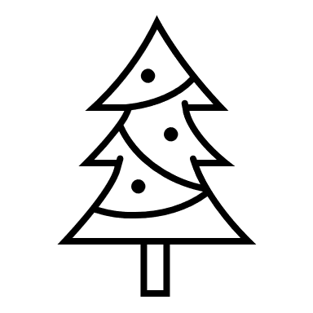  18  Christmas In July | 19  Camp Out
22  Lockdown  10:00 | 23 | 24 | 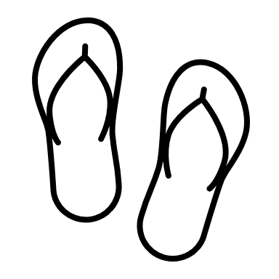  25 | 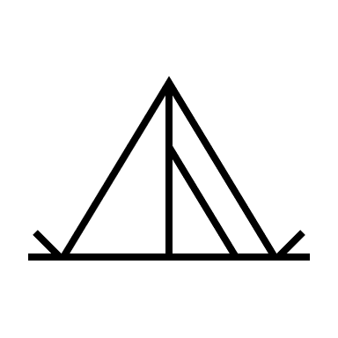  26
29 | 30 | 31

