Monday | Tuesday | Wednesday | Thursday | Friday
3 | 4 | 5 | 6  Soccer Shots Summer Session Begins | 7  GCS & NCPreK  Last Day!
10 Splash Day  Begins |   11 | 12 | 13 | 14      Father's Day Root Beer & Pretzels  3-5
17 | 18 | 19 | 20 | 21
24  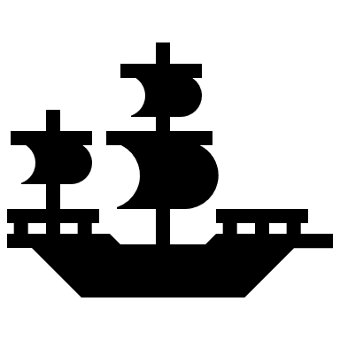  Pirate Day! |   25  Animal Day |   26  Mustache Day | 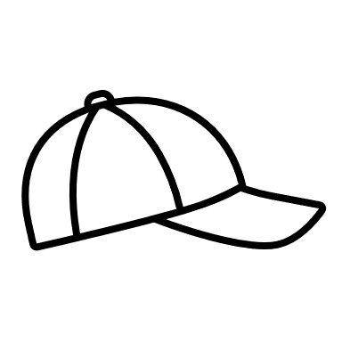  27  Hat  Day | 28  NEON DAY  Beach Party
 |  |  |  | 

