Monday | Tuesday | Wednesday | Thursday | Friday
1 Dr. Seuss
Birthday Party!
Wear Many Colors
4 | 5 | 6 | 7 | 8  Wear Purple  International Women’s Day
11 | 12 | 13 | 14 | 15  Green Party!!  Wear Green  For St. Patrick’s Day
18 | 19  1st Day of Spring | 20  Infant, Toddler, Preschool  Spring Pictures | 21  JrPreK, PreK, NCPreK  Spring Pictures | 22  Pajama Day
25 | 26 | 27  Easter Egg Hunts | 28  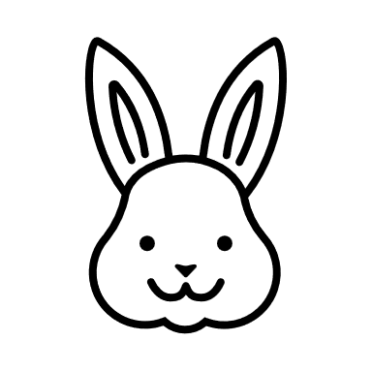  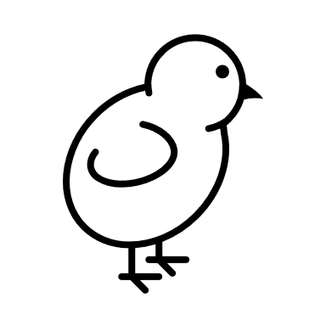  Easter Egg Parties | 29  Milestones Closed

